EYFS Home Learning
Autumn 1
The activities in this document mirror the teaching and learning taking place in the classroom this term. Please do aim to complete some of these activities alongside reading together every day, work can be submitted via Class Dojo.

Find a photograph of you when you were younger and discuss one of the ways that you have changed. | Practice your number formation by writing the numbers 0-10 on paper and mixing them up. As a challenge – can you put them in the correct order? | Practice doing up buttons on your shirt or cardigan. Maybe you can try doing them on your dolls or teddies.  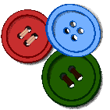 | Use some paint to make handprints of everyone’s hands in your family and then cut out the handprints. Can you put them in order of size from the smallest handprint to the largest handprint?
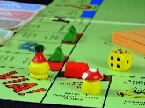  Play a board game together, such as snakes and ladders to encourage turn taking and working together. | Draw a picture that shows all of the people who are special to you. Is there anyone from school on your picture? Think about who can help you at home and school. | Sit quietly and listen carefully to see what you can hear. Draw pictures of some of the things you could hear in your house or garden. | Ask a grown-up to draw a spotty snake. How many spots does it have? Can you count them? Can you draw a snake that has one less spot?
Ask a grown-up to write some words for items in the house, such as hat, toy, chair, bed, sink. Go on a hunt around the house and tick off all the objects on the checklist that you find. | Talk to someone at home about what you would like to do when you grow up. Try and find out a little bit more about it by talking to people who know about that role or looking in a book or on the Internet. | Go outside and enjoy time in your garden. You could plant a sunflower or sow some tomatoes and watch them grow. Take some pictures and send them on Dojo. | Draw a picture of yourself and label the body parts. Do you know what they all do? Can you think about your senses?  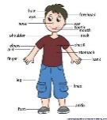  This Photo by Unknown Author is licensed under CC BY-NC-ND
Bake or prepare food together. Follow a set of instructions and make something yummy, such as a cake, biscuits or sausage rolls | Write a list of three things you can do to help you to stay healthy.  This Photo by Unknown Author is licensed under CC BY | Spread out big pieces of paper with letters written on them on the floor. Your grown-up can say a simple word and you can jump on and say the letters that make that word. | Go on a number hunt. Take a camera (or a phone) and take photos of any numbers you see. These could be on house doors, car registration plates, in shops, anywhere!
EYFS Home Learning
Autumn 2
The activities in this document mirror the teaching and learning taking place in the classroom this term. Please do aim to complete some of these activities alongside reading together every day, work can be submitted via Class Dojo.

Go on an autumn walk with a grown-up and collect some autumn leaves. Use these leaves to make a picture or collage.  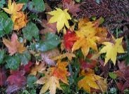  This Photo by Unknown Author is licensed under CC BY-SA | Talk about firework safety and keeping safe in the autumn. Can you draw a picture of children being safe at a firework display or with sparklers? | Learn the letters of your name by copying it with chunky chalks, or water and paintbrushes on the path or patio | Go outside when it is dark, or look out the window and talk about what you can see. Can you count the stars? Can you find the moon? Does the sky change from one night to the next?
Create a dance routine to your favourite song and perform it to your family. There are lots of ideas on Youtube to help. | Support and enjoy fine motor activities. You could try putting cereal hoops onto spaghetti or adding food colouring to pipettes for squeezing paint onto paper towels and watching the colours mix together. | Keep a weather chart for a week. Draw a picture to show what the weather is like each day.  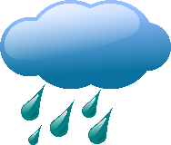 | Get all your teddies, dolls or toys and put them in height/size order. Which is the biggest and which is the smallest? How do you know?
Practice your numbers to 10 by counting toys from boxes, or items around the house. Can you write how many there are? | Create a vehicle that you could use to travel into space. What would it look like? You could create a rocket using cardboard tubes, a spacecraft using old boxes or you could design a different type of vehicle to get you there! | Have a look online for phonics videos on Youtube. Focus on a sound each day and see if you can spot it in a reading book. | It will soon be Diwali and Bonfire Night. Draw or paint a picture of fireworks exploding in the sky.  This Photo by Unknown Author is licensed under CC BY
Watch a Youtube of the story of Rama and Sita. This is very important for the festival of Diwali. Can you draw a picture from the story? | In autumn, many people celebrate a good harvest with a Harvest Festival. Write a list of some of the foods that farmers grow on their land.  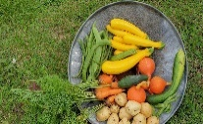  This Photo by Unknown Author is licensed under CC BY-SA | Rocket on a string - Make a simple cardboard tube rocket with a deflated balloon taped to it, thread a string through the tube and ask two people to hold either end. Then ask an adult to blow up the balloon and release it. How far will your rocket travel? | Build independence by giving a few responsibilities, such as looking after a pet, laying the table, helping with dinner or watering the plants.

