St Peter’s Church of England (Aided) Primary School Admissions Policy 2021/2022
The Governing Body of St Peter’s Church of England (Aided) Primary School adopted this policy on 29th January 2020

Signed: (Chair of Governors)

Signed: (Head Teacher)
Review Annually

St Peter’s Church of England (A) Primary School is an Academy within Embrace Multi Academy Trust. This means that the Governors are responsible for all admissions. However, for first-time admissions the Governors have requested that Leicestershire County Council, the local authority, be responsible for the control of the admission of pupils to our school and this is coordinated by the Local Authority using a common application form and timetable.

In formulating this admissions policy, the (Local) Governors consulted with Leicester Diocesan Board of Education, other Diocesan Boards of Education, local academies, Leicestershire County Council and the required governing bodies of community and voluntary controlled schools for which the Local Authority is the admission authority. This policy is reviewed by the Governing Body each Spring in line with the legal timelines for admissions. The School Admissions Code (2014) and the School Admissions Appeals Code (2012) can be found below:

https://www.gov.uk/government/publications/school-admissions-code https://www.gov.uk/government/publications/school-admissions-appeals-code

Recognising its historic foundation, the school will preserve and develop its religious character in accordance with the principles of the Church of England and in partnership with the churches at parish and diocesan level.

The school aims to serve its community by providing an education of the highest quality within the context of Christian belief and practice. It encourages an understanding of the meaning and significance of faith, and promotes Christian values through the experience it offers to all its pupils. Parents have the right to withdraw their children from the daily Christian act of worship and from Religious Education.

St Peter’s C of E (A) Primary School serves the catchment area shown in the attached Appendix.

The admissions authority will set a planned admissions number (PAN) which indicates the minimum number of places available within the year(s) of entry. This information will explain how places will be allocated until the PAN is reached at which point the governors will consider whether the resources available at the time will enable additional places to be made available. If not, the decision will be to refuse all applications that would lead to admission of pupils above PAN.

Our planned admission number (PAN) for 2021/2022 is 30 pupils.

Our designated catchment area does not prevent parents who live outside this area from expressing a preference for our school. Entitlement to a place in the school is dependent on the parents applying at the appropriate time and (for infant submissions) on compliance with infant class size regulations (1). If a child moves into the school’s designated catchment area once allocation decisions have been made, they will not necessarily be offered a place in the school if the planned admission number for that year has been reached.

Applications for places for the reception class need to be registered by completing the on-line Local Authority common application form (available from www.leics.gov.uk/admissions) and the school’s own application form.

The Local Authority common on-line application form must be completed by mid January, 2021. The School’s supplementary information form must be returned to the school office by 31st January, 2021.

The decision of the school’s Admissions Committee will be notified to parents by the Local Authority. The closing date for Local Authority applications and the notification of the decision are in accordance with the Co-ordinated Admissions Scheme (2). Late applications will not be offered a place within the school if the infant class has thirty pupils, regardless of distance to the next nearest available school. Any application received after the closing date will be treated as a mid-term application and places will be allocated according to the school’s admissions criteria and planned admission number (PAN) for that year.

Parents may seek a place for their child outside their normal age group, for example, if the child is gifted and talented, has experienced problems such as ill health or if they are moving from overseas and their child has not been educated in the English school system. Parents should contact the Head Teacher to discuss any such requests with all the relevant information taken into account. Parents may also wish to submit other information in support of their request; for example from professionals who have worked with their child. Each request will be looked at on an individual basis with any decisions taken according to what is considered to be the child’s best interests.

In addition, the parents of a summer born child (those born from 1st April to 31st August) may choose not to send that child to school until the September following their 5th birthday and may request that they are admitted out of their normal age group – to Reception rather than Year 1. In such cases the following process should be followed in order:

- Parents should make the request to Leicestershire LA by 1st December of the year before the child turns 4. This will provide time for requests to be processed, and where a request is not agreed, for the family to have adequate time to make an application before the published closing date.

- Parents should submit to Leicestershire LA their reasons for wishing to defer applying for a school place. This should include confirmation of agreement to the proposal from the Head Teacher. On receiving the supporting evidence, and on the recommendation of the Head Teacher, Leicestershire LA will write to the parent to agree that the application can be processed for the following year. However, the letter will highlight the potential risks/impact of this deferral which include:
- Whilst the school has agreed to the deferral, there is no guarantee that the child will be allocated a place at that school the following year.
- Should it not be possible to allocate a place at the school the following year, the local authority will make every effort to allocate a Reception place, rather than a Year 1 place. However, it may not be possible to do this. Decisions on which year group a child is admitted to are taken by a school’s admission authority; this is not always the local authority and the admission authority of alternative schools may not be in agreement with deferred entry.
- Parents will also be made aware that deferring entry will have an impact on their child’s score should they sit the 11+ test. This is due to the age standardisation process.
- Attention will also be drawn to the fact that when the child moves to a different school (e.g. primary to secondary, or due to a house move) that the admission authority of the new school will be responsible for deciding which year group the child will be placed in. This could result in a child being required to ‘skip’ a year.

- If the request is not agreed, the parent will receive a letter detailing the reasons why.

- A copy of the letter sent to the parent will be sent to the Head Teacher.

- The parent may still change their mind regarding deferred entry by a whole school year, and submit an application in the normal way. If an application is received then the parent’s previous request to defer until the following year would no longer apply. This will offer the following options to the parent:
- Their child starts school in the September following their 4th birthday;
- They can consider deferring the child’s start date in Reception until later in the school year;
- They can discuss part-time arrangements with the allocated school, as detailed above.

- A parent who chooses to defer entry by a whole school year will need to apply for a school place in the admissions round for the following year in the normal way. Their application will then be considered in exactly the same way as all others submitted during that application year.

If a parent who has applied by the closing date given by the Local Authority later changes their mind and wishes to defer their child’s entry to Reception, they should discuss this and other options with the Head Teacher. Requests to defer will not be agreed if the only reason is that a place has not been offered at one of the preferred schools.

These applications for admission outside normal age group will be considered alongside all other applications in accordance with the Local Authority co-ordinated admissions scheme. Parents have a statutory right to appeal against the refusal of a place at the school for which they have applied. This right does not apply if they have been offered a place at the school but it is not in their preferred age group.

Children with an Education, Health and Care Plan (or Statement of Special Educational Need) naming the school will be admitted even if this means exceeding the agreed PAN. Otherwise, when there are more applications than there are places available, the governors will admit pupils according to the following criteria which are listed in order of priority. If there are fewer applications than places, then no application is refused. If there are too many requests, priority will be given to children whose parents applied on time, in the following order

- A child who is ‘looked after (3)’ or ‘previously looked after.’
Previously looked after children are children who were looked after, but ceased to be so because they were adopted (4) or became subject to a residence order (5) or special guardianship order (6).
- Pupils who have a serious medical condition or exceptional social or domestic needs. (Professional documentation accompanying the application will be required). Examples of exceptional needs include:
  - A child whose parent’s occupation has an enforcement role which may bring the parent into conflict with parents of children attending their local school and therefore needs to attend the alternative school.
  - A child whose parent has recently died or is suffering from a serious illness.
  - A child who has suffered severe bullying which is recognised by the present or most recent school as an ongoing problem and which is having significant effect on the child’s health.
  - A child with a serious medical condition which would make the preferred school particularly suitable
  - A child who has been abused and placed on the child protection register and who needs to attend an alternative school to avoid the abuser
This list is not exhaustive, and each case will be considered on its individual merits.
- Pupils who will have an older sibling attending the school at the time of admission and live in the designated catchment. (Older siblings include brothers or sisters, half brothers or sisters, step brothers or sisters, adopted children, fostered children, children of partners living together or any other child who permanently resides at the parental home and for whom the parent has parental responsibility).
- Pupils who will have an older sibling attending the school at the time of admission. (Older siblings include brothers or sisters, half brothers or sisters, step brothers or sisters, adopted children, fostered children, children of partners living together or any other child who permanently resides at the parental home and for whom the parent has parental responsibility).
- Pupils who live in the designated catchment (See appendix). The child’s place of residence is taken to be the parental home.
- All other pupils.

In the event that there are more applications than places available in any of the above criteria, places will be allocated by a method of random allocation (drawing lots) that will be observed by an independent witness.

In exceptional cases the school has the right to withdraw an offer of a place where a parent has not responded to an offer within 21 days, or where the place has been obtained by false information, for example an incorrect address or date of birth. Offers of places may also be withdrawn if they were based on an address and the parent’s address changes before the child is admitted. For example, if a child was offered a place and the family moves out of catchment before admission takes place, the offer of the place is withdrawn. This is regardless of numbers in the school and whether or not other requests have been refused

Waiting Lists

During the normal admissions round it is always necessary to complete a Local Authority Common Application form to apply for a school place. Registering interest with the school on a ‘waiting list’ before the admissions round guarantees neither a place nor priority within the priority Criteria. Offers of places will be made by the Local Authority on the school’s behalf.

If the school receives more applications than there are places available for children due to start in 2021-22, then a waiting list will be maintained. The position on the list will be determined by applying the published priority criteria and not by date of receipt. Each name added will require the list to be re-ranked. The existence of a waiting list does not remove the right of appeal against any refusal of a place from any unsuccessful applicant.

Names will only be removed from the list if a written request is received, or if the offer of a place that becomes available is declined. The waiting list will shut down on 31 December 2021 in accordance with statutory requirements. Looked after children and previously looked after children as defined within this policy, children who are the subject of a direction by a local authority or who are allocated to a school in accordance with a Fair Access Protocol will take precedence over any child on the waiting list.

If the Admissions Committee are unable to offer a place the parents/carers have the right to appeal. Appeals should be sent to: Diocesan Director of Education, St. Martins House, 7 Peacock Lane, Leicester, LE1 5PZ. The appeal must be in writing on the relevant form which can be obtained from the Clerk to the appeals panel, Diocesan Board of Education, St. Martins House, 7 Peacock Lane, Leicester, LE1 5PZ or via our website at https://www.leicester-dbe.com/admissions-appeals/ . Appeals must be made by 30th April in writing on the relevant form, and appeals will be heard during the summer term, within 40 school days of this date. Appeals lodged after this deadline, like appeals for in-year admissions, will be heard within 30 school days of the appeal being lodged. In all cases, appellants will receive at least 10 days’ written notice of the appeal hearing. They may submit additional evidence in writing by 12 noon the day before the hearing. Decision letters are sent to the school and appellant within 5 days of the hearing.

Notes:
- Education (Infant Class Sizes) (England) Regulations 1998
- The Co-ordinated Admissions Scheme is available for inspection through Allocations, Leicestershire County Council, County Hall, Glenfield, Leicestershire, LE3 8RF
- A 'looked after child' is a child who is (a) in the care of a local authority, or (b) being provided with accommodation by a local authority in the exercise of their social services functions (see the definition in Section 22(1) of the Children Act 1989) at the time of making an application to a school.
- Under the terms of the Adoption and Children Act 2002. See Section 46 (adoption orders).
- Under the terms of the Children Act 1989. See Section 8 which defines a „residence order‟ as an order settling the arrangements to be made as to the person with whom the child is to live.
- See Section 14A of the Children Act 1989 which defines a „special guardianship order‟ as an order appointing one or more individuals to be a child’s special guardian (or special guardians).

Full consultation review 2024 or earlier if changes required.
Appendix 1: map of designated catchment
Appendix 2: copy of school’s supplementary admissions information form

Appendix 1
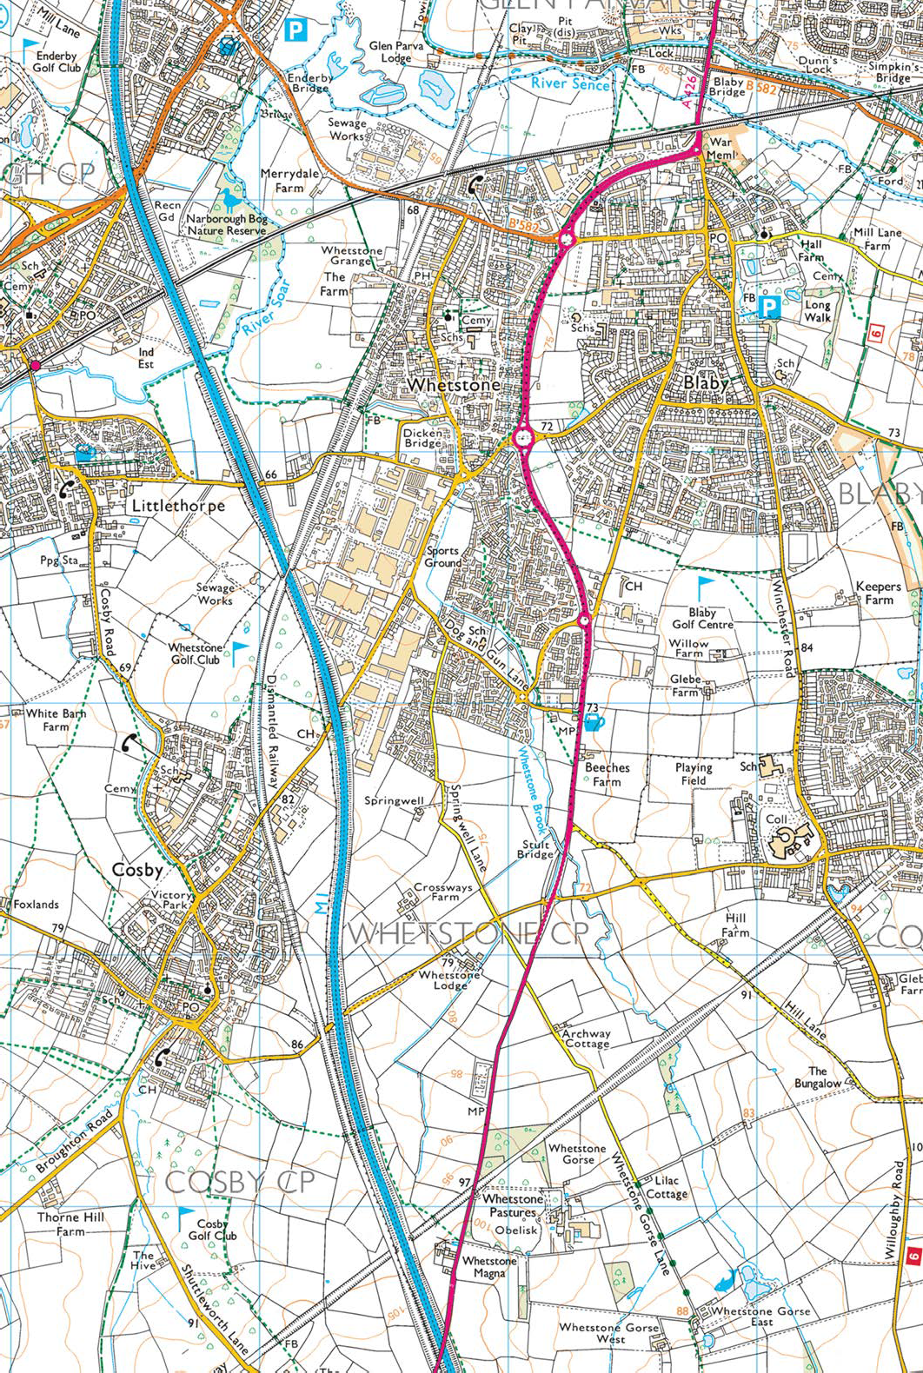
Based upon the ordance survey mapping with the permission of the Controller of Her Majesty’s Stationery Office.

©Crown copyright. Unauthorised Reproduction infringes Crown copyright and might lead to prosecution or civil proceedings.
Leicestershire County Council Licence No. LA 076724.
Catchment Boundaries
Badgerbrook
St Peter’s

Appendix 2
St Peter’s Church of England (Aided) Primary School
Wale Road, Whetstone, LE8 6NJ
Application Form for Admission
St Peter’s is a Church Aided Primary School and so the Governing Body have their own Admissions Policy. Copies of this are available in the school office and a summary can be found in the School Brochure. It is important that governors have the information requested on this form to help them allocate places to children if the school is oversubscribed. This form, together with any supporting letters, is made available to the Appeals Panel in the case of any appeal against non-admission. In all other respects, information given is treated as confidential. If you have any difficulty in completing any part of the form, please telephone the school and talk to the head teacher. Please ensure details are correct. Thank you for your help.

SECTION A TO BE COMPLETED BY ALL APPLICANTS/SECTION B IS OPTIONAL

SECTION A
CHILD’S DETAILS:
Surname Forenames Home Address
Post Code Home Telephone Number Date of Birth
Present School/ Nursery/Playschool (if applicable)
PARENTS’/PERSON WITH LEGAL RESPONSIBILITY FOR THE YOUNG PERSON DETAILS:
Title Initials Surname Title Initials Surname

Is the pupil “in the care of” a Local Authority | Yes/No
If yes, which Local Authority?
Does the pupil have a Statement of Special Education Need? Naming our school.
Has a sibling already in school on the date of admission.

I/We wish my/our child to be admitted to this Church Aided School and confirm that the information
on this form is correct.
________________________________________ / ____________________________________________
Signature(s) of parent(s)/person with legal responsibility for the young person

Date________________________________

