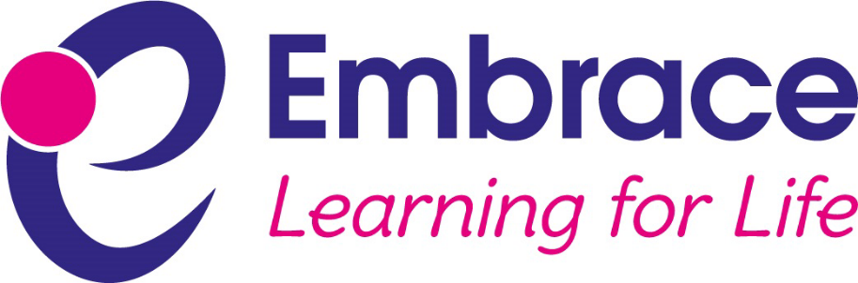

Social Media Code of Conduct for Parents/Carers and the Wider Community

Embrace Multi Academy Trust strives to maintain and improve good provision and outcomes at each of its member academies. Based upon our shared values and ethos, we aim to support the learning and development of every person within the trust and our policies are written from this perspective.

Signature: …………………………………………… Date: ………………………………………

Printed Name: ……………………………………… Position: …………………………………..

Date of Review | November 2020
Next Review | November 2022
Approval By | Trust Leader
Review Frequency | Every two years

Statement of intent

Embrace Multi Academy Trust understands the benefits of using social media; however, if misused, the trust and/or academy community can be negatively affected. This code of conduct sets out clear procedures for how we expect parents/carers and the wider community to conduct themselves when using social media.

Application of the code of conduct

This code of conduct is in place to outline appropriate and expected use of social media across all schools within Embrace Multi Academy Trust.
The code of conduct is relevant to the use of all forms of social media, including all social networking sites, internet postings, blogs and chat apps.
This code of conduct applies to parents and carers and to members of the wider community. Members of staff at the trust and within schools must conduct themselves in line with the staff acceptable use policy and staff code of conduct; pupils are expected to comply with the school behaviour policy and the pupil acceptable use policy; and trustees and governors have a separate code of conduct.

Legal framework

This policy has due regard to statutory legislation, including, but not limited to, the following:
- Data Protection Act 1998
- Defamation Act 2013
- Protection of Freedoms Act 2012 (as amended)

Expected social media conduct

Embrace Multi Academy Trust expects civilised online behaviour from all stakeholders and will not tolerate any of the following social media behaviour:
- Sending abusive messages to anyone employed at or connected with any trust academy or the trust
- Sending abusive messages about anyone employed at or connected with any trust academy or the trust
- Posting defamatory ‘statuses’ about anyone employed at or connected with any trust academy or the trust
- Using social media to complain or post any grievances about the trust or any academy values and methods.
The academy has a complaints policy in place, to avoid broadcasting grievances online.
Parents/carers and the wider community will be made aware of their responsibilities regarding their use of social media. This code of conduct will be published on the trust and all trust academy websites.
Breaches of this code of conduct will be taken seriously by the trust and/or individual academies and, in the event of illegal, defamatory, or discriminatory content, breaches could lead to prosecution.
Parents will not attempt to ‘friend’ or ‘follow’ any member of staff on social media.
Embrace Multi Academy Trust retains the right to request that any potentially damaging comments or material are removed from social media platforms.

Actions to be considered by the trust or individual academies in the event of non-compliance with this code of conduct

Following any non-compliance with this code of conduct, the trust and/or individual academies will consider a response that could involve one or more of the following actions dependent upon the nature of the non-compliance:
- Contact individuals directly, to stop issues continuing
- Request a meeting with individuals
- With the permission of the individuals concerned, view messages sent between individuals in order to deal with problems quickly and effectively
- Ask individuals to remove comments immediately
- Request that ‘group chats’ are closed down, should any problems exist between individuals
- Report the matter to the appropriate 'report abuse' section of the particular site
- Set out the school’s concerns to the individual in writing, giving them a warning and requesting that the material in question is removed
- Contact the host/provider of the social networking site to complain about the content of the site and ask for removal of the information
- Take legal advice and/or legal action where the information posted is defamatory in any way or if the circumstances warrant this
- Contact the police where the school feels it appropriate, for example, if it considers a crime (such as harassment) has been committed or in cases where the posting has a racial element, is considered to be grossly obscene or is threatening violence.

Appendix A: Letter to Parents

Dear Parents/Carers
Re: Social media code of conduct
As a school, we appreciate and understand the benefits of social media for use by all within the community. However, whilst there are many positive benefits to using social media, there are also some significant negative impacts that can unfairly affect individuals within our community. Embrace Multi Academy Trust and our school are keen to do all that we can to prevent this taking place.
In order for us to set the best example possible to our children, we have strict policies in place relating to the use of social media, that all members of staff, governors and trustees are bound by. We would like to share the Embrace social media code of conduct for parents/carers and the wider community with you, which is available on the school website via the following link (ADD LINK).
The purpose of the code of conduct is to lay out our expectations for the school community in relation to the use of social media, in matters linked to the school. We have also detailed our potential response to online abuse, which may include considering our legal options to deal with any defamatory or libellous activity on social media.
If you have any concerns or questions on this matter, please contact me via the school office.
Yours sincerely

Headteacher

