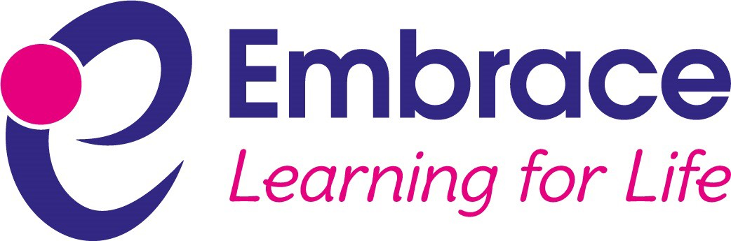

Equality Information and Objectives

Embrace Multi Academy Trust strives to maintain and improve good provision and outcomes at each of its member academies. Based upon our shared values and ethos, we aim to support the learning and development of every person within the trust and our policies are written from this perspective.

Signature: …………………………………………… Date: ………………………………………

Printed Name: ……………………………………… Position: …………………………………..

Date of Review | January 2020
Next Review | January 2024
Approval By | Trust Leader
Review Frequency | Every 4 years or DfE or legal changes

Aims

  - Our trust aims to meet its obligations under the public sector equality duty by having due regard to the need to:
- eliminate discrimination and other conduct that is prohibited by the Equality Act 2010
- advance equality of opportunity between people who share a protected characteristic and people who do not share it
- foster good relations across all characteristics – between people who share a protected characteristic and people who do not share it.

Legislation and guidance

  - This document meets the requirements under the following legislation:
- The Equality Act 2010, which introduced the public sector equality duty and protects people from discrimination
- The Equality Act 2010 (Specific Duties) Regulations 2011, which require schools to publish information to demonstrate how they are complying with the public sector equality duty and to publish equality objectives

  - This document is also based on Department for Education (DfE) guidance: The Equality Act 2010 and schools and complies with our funding agreement and articles of association.

Roles and responsibilities

  - The local governors will:
- ensure that the equality information and objectives as set out in this statement are published and communicated throughout their school, including to staff, pupils and parents
- delegate responsibility for monitoring the achievement of the objectives on a daily basis to the headteacher.
  - The headteacher will:
- promote knowledge and understanding of the equality objectives amongst staff and pupils
- monitor success in achieving the objectives and report back to governors.
  - All school staff are expected to have regard to this document and to work to achieve the objectives as set out in section 8.

Eliminating discrimination

  - The trust and all schools are aware of their obligations under the Equality Act 2010 and comply with non-discrimination provisions.

  - Where relevant, our policies include reference to the importance of avoiding discrimination and other prohibited conduct.

  - All members of staff and governors are regularly reminded of their responsibilities under the Equality Act, for example during meetings. Where this has been discussed during a meeting, it is recorded in the meeting minutes.

Advancing equality of opportunity

  - As set out in the DfE guidance on the Equality Act, the trust and all schools aim to advance equality of opportunity by:
- removing or minimising disadvantages suffered by people which are connected to a particular characteristic they have (eg pupils with disabilities, or gay pupils who are being subjected to homophobic bullying)
- taking steps to meet the particular needs of people who have a particular characteristic (eg enabling Muslim pupils to pray at prescribed times)
- encouraging people who have a particular characteristic to participate fully in any activities (eg encouraging all pupils to be involved in the full range of school activities).

  - In fulfilling this aspect of the duty, the trust and all schools will:
- review attainment data showing how pupils with different characteristics are performing
- analyse the above data to determine strengths and areas for improvement and implement actions in response
- review the evidence available to identify improvements for specific groups (eg declines in incidents of homophobic or transphobic bullying)
- publish further data about any issues associated with particular protected characteristics, identifying issues that could affect our pupils.

Fostering good relations

  - The trust and schools aim to foster good relations between those who share a protected characteristic and those who do not share it by:
- promoting tolerance, friendship and understanding of a range of religions and cultures through different aspects of our curriculum. This includes teaching in RE, citizenship and personal, social, health and economic (PSHE) education, but also activities in other curriculum areas. For example, as part of teaching and learning in English/reading, pupils will be introduced to literature from a range of cultures
- holding assemblies to discuss relevant issues
- working with our local community. This includes inviting leaders of local faith groups to speak at assemblies, and organising school trips and activities based around the local community
- encouraging and implementing initiatives to deal with tensions between different groups of pupils within schools. For example, school councils have representatives from different year groups and is formed of pupils from a range of backgrounds. All pupils are encouraged to participate in the school’s activities, such as sports clubs. We also work with parents to promote knowledge and understanding of different cultures
- we have developed links with people and groups who have specialist knowledge about particular characteristics, which helps inform and develop our approach.

Equality considerations in decision-making

  - Schools ensure that they have due regard to equality considerations whenever significant decisions are made.

  - Schools always consider the impact of significant decisions on particular groups. For example, when school trips or activities are being planned, schools consider whether the trip:
- cuts across any religious holidays
- is accessible to pupils with disabilities
- has equivalent facilities for boys and girls.

Equality objectives

  - All schools within the trust have agreed to focus upon the following objectives from 2020 to 2024:

Objective 1
Actively close gaps in attainment and achievement between all groups of students; especially students eligible for free-school meals, students with special educational needs and disabilities, looked after children, students from minority ethnic groups and across genders.

Objective 2
Promotion of cultural understanding, awareness and respect of different religious beliefs between different ethnic groups within our school communities and thus continue to reduce the number of all prejudice based incidents.

Objective 3
Strive to ensure high attendance of all disadvantaged pupils to diminish gaps between the attendance of disadvantaged children and other pupils.

Objective 4
Ensure fair access to the curriculum offer for those with differing abilities, including access to appropriate pathways, and through promoting inclusive approaches to teaching and learning.
Objective 5
Endeavour to ensure that governance and the staff body and representation of staff in leadership roles is reflective of the local community.

Objective 6
Continue to provide opportunities for all parents/carers to participate in the life of the schools.

